

**PATIENT ENGAGEMENT SYSTEM**

**MINI PROJECT REPORT**

**Submitted by**

**Kaviya P (231801082)**

**Madhan P (231801089)**

**CS23333 OBJECT ORIENTED PROGRAMMING**

**USING JAVA**

**Department of Artificial Intelligence and Data Science**

**Rajalakshmi Engineering College Thandalam**

# BONAFIDE CERTIFICATE

Certified that this project report “**PATIENT MANAGEMENT SYSTEM**” is Bonafide work

of “**KAVIYA P** (231801082), **MADHAN** (231801089)”who carried out the project work under my supervision.

**Submitted for the Practical Examination held on**

# SIGNATURE SIGNATURE

**Mrs.RENUKA DEVI Dr.GNANASEKAR J M**

Assistant Professor,Artificial Intelligence Head of the Department,Artificial

and data Science,Rajalakshmi engineerning intelligence and data science,

College, Rajalakshmi Engineering College,

Thandalam,Chennai-601205 Thandalam,Chennai-601205

# 

# 

**INTERNAL EXAMINER EXTERNAL EXAMINER**

|  |
| --- |
| MINIPROJECT |

|  |
| --- |
| **ABSTRACT**      The Patient Engagement System is a comprehensive platform designed to bridge the communication gap between patients and healthcare providers, enhancing the overall quality of healthcare delivery. By providing an intuitive interface for users, the system streamlines essential functions such as appointment scheduling, medication adherence tracking, and access to medical records. Patients can easily view their appointment history, contact their doctors, and receive timely reminders for medications, ensuring adherence to prescribed treatments.  The system utilizes a secure backend architecture to manage user data, including patient and doctor profiles, while prioritizing data privacy and compliance with healthcare regulations. It features robust authentication mechanisms to safeguard sensitive information and employs a user-friendly design to facilitate easy navigation for individuals with varying levels of technological proficiency.    Through the integration of various functionalities, such as messaging capabilities and appointment management, the Patient Engagement System aims to empower patients to take an active role in their healthcare journey. By fostering better communication and providing easy access to vital health information, this platform not only improves patient satisfaction but also contributes to better health outcomes and a more efficient healthcare system.  Furthermore, the platform is designed with a focus on accessibility, catering to individuals with varying levels of technological expertise. Through intuitive navigation and streamlined workflows, users can easily access vital health information and communicate with their healthcare providers, regardless of their technical proficiency. This inclusivity fosters a sense of community and support, vital for patient satisfaction and well-being.  By promoting better communication between patients and providers, the Patient Engagement System contributes to improved health outcomes and patient satisfaction. The system not only enhances the quality of care but also empowers patients to take control of their health journey, ultimately leading to a more efficient and patient-centered healthcare system. In an era where technology plays an increasingly vital role in healthcare, this system stands as a pivotal solution for enhancing patient engagement and transforming healthcare delivery |

|  |  |  |  |  |  |  |  |  |  |  |  |  |  |  |  |  |  |  |  |  |  |  |  |  |  |  |  |  |  |  |  |  |  |  |  |  |  |  |  |  |  |  |  |  |  |  |  |  |  |  |  |  |  |  |  |  |  |  |  |  |  |  |  |
| --- | --- | --- | --- | --- | --- | --- | --- | --- | --- | --- | --- | --- | --- | --- | --- | --- | --- | --- | --- | --- | --- | --- | --- | --- | --- | --- | --- | --- | --- | --- | --- | --- | --- | --- | --- | --- | --- | --- | --- | --- | --- | --- | --- | --- | --- | --- | --- | --- | --- | --- | --- | --- | --- | --- | --- | --- | --- | --- | --- | --- | --- | --- | --- |
| **APPENDIX LIST OF CONTENT**   |  |  |  | | --- | --- | --- | | CHAPTER NO. | TITLE | PAGE NO. | |  | ABSTRACT | 4 | | 1 | INTRODUCTION | 7 | |  | 1.1 OBJECTIVE | 7 | | 2 | SYSTEM ANALYSIS | 9 | |  | 2.1 EXISTING SYSTEM  2.2 PROPOSED SYSTEM | 9 | |  | 10 | | 3 | SYSTEM REQUIREMENT | 11 | |  | 3.1 HARDWARE REQUIREMENT  3.2 SOFTWARE REQUIREMENT | 11 | |  | 11 | | 4 | SYSTEM IMPLEMENTATION | 12 | |  | 4.1 MODULE LIST  4.2 MODULE DESCRIPTION  4.2.1 REGISTRATION MODULE  4.2.2 LOGIN MODULE | 12 | |  | 13 | |  | 13 | |  |  | | 5 | TESTING | 14 | |  | 5.1 TESTING OBJECTIVE  5.2 TEST CASE | 15 | |  | 16 | | 6 | CONCLUSION | 17 | |  |  |  | |  | APPENDIX 1 (SAMPLE CODING) | 18 | |  | APPENDIX 2 (SNAPSHOT) | 23 | |  | REFERENCES | 25 | |

|  |
| --- |
| **CHAPTER – 1**  **INTRODUCTION**  1.1 OBJECTIVE    This solution aims to enhance the overall patient experience and streamline healthcare processes by establishing seamless communication between patients and providers, improving appointment management, and promoting medication adherence through timely reminders. It offers easy access to medical records and health information, empowering patients to actively participate in their care and make informed decisions. The platform prioritizes data security and privacy, ensuring compliance with healthcare regulations. Additionally, it enhances user experience with an intuitive interface and supports health monitoring, enabling proactive management. By automating administrative tasks and gathering patient feedback, the system reduces the workload for healthcare providers while fostering continuous improvement in patient care.    This comprehensive platform enhances patient-provider communication, allowing for timely exchanges and feedback, while simplifying appointment management with an intuitive scheduling system. It promotes medication adherence through reminders and alerts, helping patients stay on track with their treatments. Patients are empowered with easy access to their medical records and health information, enabling informed decision-making about their healthcare. The platform ensures robust data security, complying with privacy regulations, and is designed to cater to users with diverse technological abilities. Additionally, it supports health monitoring and proactive care management, streamlines administrative processes, and encourages continuous improvement by gathering patient feedback, ultimately improving both patient experience and healthcare delivery. |

|  |
| --- |
| **CHAPTER – 2**  **SYSTEM ANALYSIS**  2.1 EXISTING SYSTEM  The existing patient engagement systems in many healthcare settings often rely on traditional methods of communication, such as phone calls and in-person visits. Some of the key features of the current systems include:   1. Limited Communication Channels: Patients typically communicate with their healthcare providers through phone calls or face-to-face interactions, which can lead to long wait times for responses and potential miscommunications. 2. Manual Appointment Scheduling: The appointment booking process is often handled manually, either by phone or through paper-based systems, leading to inefficiencies, scheduling conflicts, and increased administrative workload.   2.2 PROPOSED SYSTEM  The proposed Patient Engagement System aims to address the limitations of the existing systems by implementing a comprehensive digital platform that enhances communication, access to information, and patient involvement. Key features of the proposed system include:   1. Multichannel Communication: The system provides various communication channels, including secure messaging, video calls, and chat options, allowing for timely and efficient interactions between patients and healthcare providers. 2. Automated Appointment Scheduling: Patients can easily book, modify, or cancel appointments through an intuitive online interface, reducing administrative burdens and minimizing scheduling conflicts. 3. Centralized Health Information Access: The platform enables patients to access their medical records, test results, and other essential health information at any time, empowering them to make informed decisions about their care. 4. Automated Medication Reminders: The system includes features to send automated reminders to patients for taking medications, which can help improve adherence and reduce health risks. 5. Integrated Health Monitoring: Patients can track their health metrics (such as weight, blood pressure, and exercise) within the system, enabling healthcare providers to monitor progress and make informed adjustments to treatment plans |

|  |  |
| --- | --- |
|  | **CHAPTER–3**  **SYSTEM REQUIREMENT** |
| 3.1 | HARDWARE REQUIREMENT  Hard Disk : 10GB and Above  RAM : 512MB and Above  Processor : Core i5  Speed : 2.2GHz |
| 3.2 | SOFTWARE REQUIREMENT  Platform : JAVA  Front End Tools : Visual Studio 2010  Back End Database : SQL Server 2008 |

|  |
| --- |
| **CHAPTER – 4**  **SYSTEM IMPLEMENTATION**  4.1 MODULE LIST   * Registration Module * Login Module * Dashboard Module * Appointment Management Module • Medication Reminder Module * Health Information Access Module * Communication Module * Feedback and Support Module * Security and Compliance Module   4.2 MODULE DESCRIPTION   * + 1. REGISTRATION MODULE   The Registration Module allows new users to create accounts within the Patient Engagement System   * + 1. LOGIN MODULE   The Login Module enables users to securely access their accounts within the Patient Engagement System   * + 1. DASHBOARD MODULE   The Dashboard Module serves as the central interface for users, displaying relevant information and quick access to various features based on user roles.  4.24 APPOINTMENT MANAGEMENT MODULE  This module allows patients to schedule, reschedule, and cancel appointments with healthcare providers through an intuitive interface.  4.2.5 MEDICATION REMINDER MODULE  The Medication Reminder Module sends automated reminders to patients for taking their prescribed medications on time |

|  |  |  |  |  |  |  |  |  |  |  |  |  |  |  |  |  |  |  |  |  |  |  |  |  |  |  |  |  |
| --- | --- | --- | --- | --- | --- | --- | --- | --- | --- | --- | --- | --- | --- | --- | --- | --- | --- | --- | --- | --- | --- | --- | --- | --- | --- | --- | --- | --- |
| **CHAPTER – 5**  **TESTING**  5.1 TESTING OBJECTIVE  The primary objectives of testing the Patient Engagement System are as follows:   1. Functionality Verification: Ensure all functionalities (registration, login, appointment management, etc.) work as intended and meet user requirements. 2. Usability Assessment: Evaluate the system's user interface for intuitiveness and ease of use, ensuring that users can navigate without confusion. 3. Security Validation: Test the system's security measures to protect user data from unauthorized access and breaches. 4. Performance Evaluation: Assess the system's performance under different loads to ensure it can handle concurrent users effectively.   5.2 TEST CASES   |  |  |  |  | | --- | --- | --- | --- | | TEST CASE NAME | TEST CASE DESCRIPTION | EXPECTED OUTCOME | ACTUAL OUTCOME | | TC-001 | Verify user registration with valid data | User account is created and confirmation email is sent. | PASS | | TC-002 | Verify registration with duplicate email | Error message indicating email is already registered. | PASS | | TC-003 | Verify user login with valid credentials | User is successfully logged in and redirected to dashboard. | PASS | | TC-004 | Verify login with invalid credentials | Error message indicating invalid credentials. | PASS | | TC-005 | Verify appointment booking functionality | Appointment is successfully booked and confirmation is displayed. | PASS | | TC-006 | Verify user logout functionality | User is successfully logged out and redirected to login page. | PASS | |

|  |
| --- |
| **CHAPTER – 6**  **CONCLUSION**  In conclusion, the patient engagement system serves as a vital bridge between healthcare providers and patients, enhancing communication and streamlining processes such as appointment scheduling, medication adherence, and health information access. By offering secure and user- friendly features, the platform not only empowers patients to take an active role in managing their health but also enables healthcare providers to deliver more personalized and efficient care. As healthcare continues to evolve, such a system is essential for improving patient outcomes, fostering better relationships between patients and providers, and ensuring compliance with industry standards and regulations.  The patient engagement system represents a transformative approach to modern healthcare, addressing the critical need for improved communication, accessibility, and efficiency in patient care. By offering a comprehensive platform that allows for seamless appointment scheduling, secure messaging with healthcare providers, access to medical records, and medication reminders, this system empowers patients to actively manage their health. It fosters a collaborative relationship between patients and healthcare providers, ensuring that care is both personalized and timely. Furthermore, the system enhances healthcare delivery by providing doctors and hospitals with tools to track patient progress, anticipate needs, and offer proactive interventions. |

|  |
| --- |
| **APPENDIX 1**  CODING  registration.java package com.example.patientengagement;  import javax.servlet.ServletException; import javax.servlet.annotation.WebServlet; import javax.servlet.http.HttpServlet; import javax.servlet.http.HttpServletRequest; import javax.servlet.http.HttpServletResponse; import java.io.IOException;  @WebServlet("/register") public class RegisterServlet extends HttpServlet {  protected void doPost(HttpServletRequest request, HttpServletResponse response) throws  ServletException, IOException {  String name = request.getParameter("name");  String email = request.getParameter("email");  String password = request.getParameter("password");  Patient newPatient = new Patient(name, email, password); boolean isRegistered = DatabaseHelper.registerPatient(newPatient);  if (isRegistered) { response.sendRedirect("registration_success.jsp");  } else { response.sendRedirect("registration_error.jsp"); |

|  |
| --- |
| login.java package com.example.patientengagement;  import javax.servlet.ServletException; import javax.servlet.annotation.WebServlet; import javax.servlet.http.HttpServlet; import javax.servlet.http.HttpServletRequest; import javax.servlet.http.HttpServletResponse; import java.io.IOException;  @WebServlet("/login") public class LoginServlet extends HttpServlet {  protected void doPost(HttpServletRequest request, HttpServletResponse response) throws  ServletException, IOException {  String email = request.getParameter("email");  String password = request.getParameter("password");  Patient loggedInPatient = DatabaseHelper.loginPatient(email, password);  if (loggedInPatient != null) { response.sendRedirect("dashboard.jsp"); // Redirect to dashboard  } else { response.sendRedirect("login_error.jsp");  }  }  }  Appointment.java package java.com.example.patientengagement; |
| import java.time.LocalDateTime;  public class Appointment { private LocalDateTime dateTime; private String doctorName; private String reason;  public Appointment(LocalDateTime dateTime, String doctorName, String reason) { this.dateTime = dateTime; this.doctorName = doctorName; this.reason = reason;  }  // Getters  public LocalDateTime getDateTime() { return dateTime;  }  public String getDoctorName() { return doctorName;  }  public String getReason() { return reason;  }  @Override  public String toString() {  return "Appointment{dateTime=" + dateTime + ", doctorName='" + doctorName + "',  reason='" + reason + "'}"; |

**APPENDIX 2**

SCREENSHOT

A2.1

REGISTRATION

A2.2

LOGIN

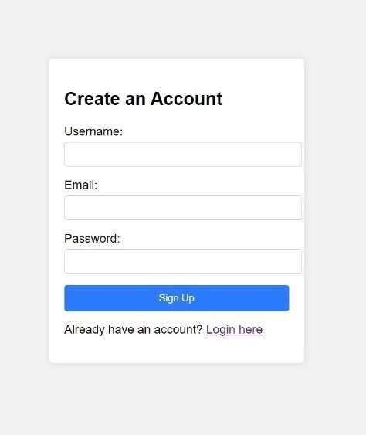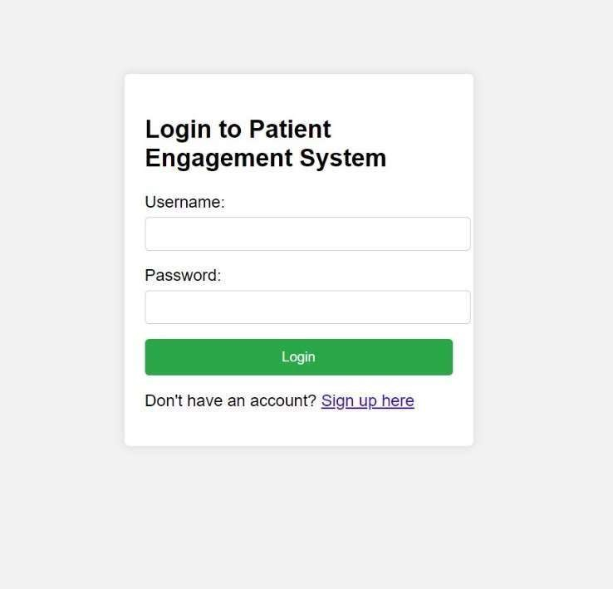

A2.3 APPOINTMENT

A2.4 VIEWING APPOINTMENT

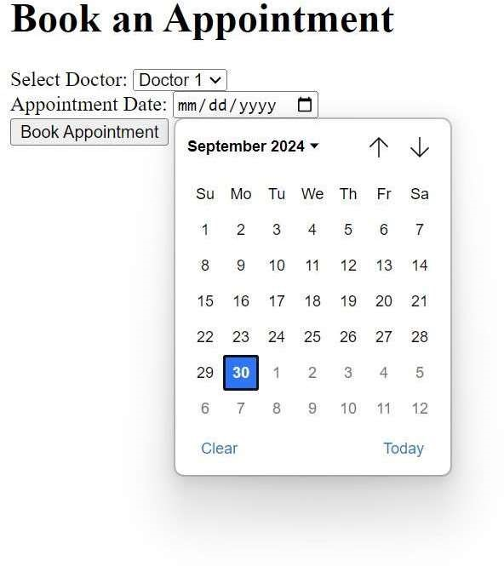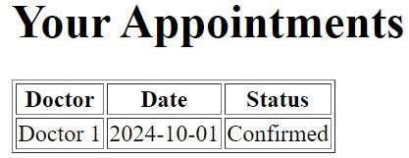

|  |
| --- |
| **REFERENCES**   1. HealthIT.gov. (n.d.). Patient Engagement.   Retrieved from [https://www.healthit.gov/topic/patient- engagement](https://www.healthit.gov/topic/patient-engagement)   1. HIMSS. (n.d.). Patient Engagement Strategies.   Retrieved from [https://www.himss.org/resources/patient-engagement- strategies](https://www.himss.org/resources/patient-engagement-strategies)   1. Mayo Clinic. (n.d.). Patient Engagement and Empowerment.   Retrieved from [https://www.mayoclinic.org/patient-visitor-guide/patient- engagement](https://www.mayoclinic.org/patient-visitor-guide/patient-engagement) |